**MFIT 5002 Group Project 1**

**Group 7**

Xunan Li, Student ID: 20832588

Ziliang Li, Student ID: 20832461

Shu Wang, Student ID: 20832332

We assume that the 3 ethers that bank register with RTGS come from the initial funding of 5 (or more) ether from the bank owner. For normal banks, the bank has an owner and only the bank owner could see the bank ledger and close the bank. For RTGS bank, we assume there’s no need to have an owner or 5 ethers initial funding to complicate the scenario.

We also assume that banks wouldn't make deposits in the RTGS bank when their clients make deposits. Therefore, any inter-bank transfer with amount greater than 3 ethers wouldn't be allowed since each bank only has 3 ethers in their accounts in the RTGS bank.

1. **Deploy RTGS (Central Bank)**

As the screenshot shows, we first deploy the RTGS bank. By clicking deploy (with central bank contract selected), central bank deployed successfully.

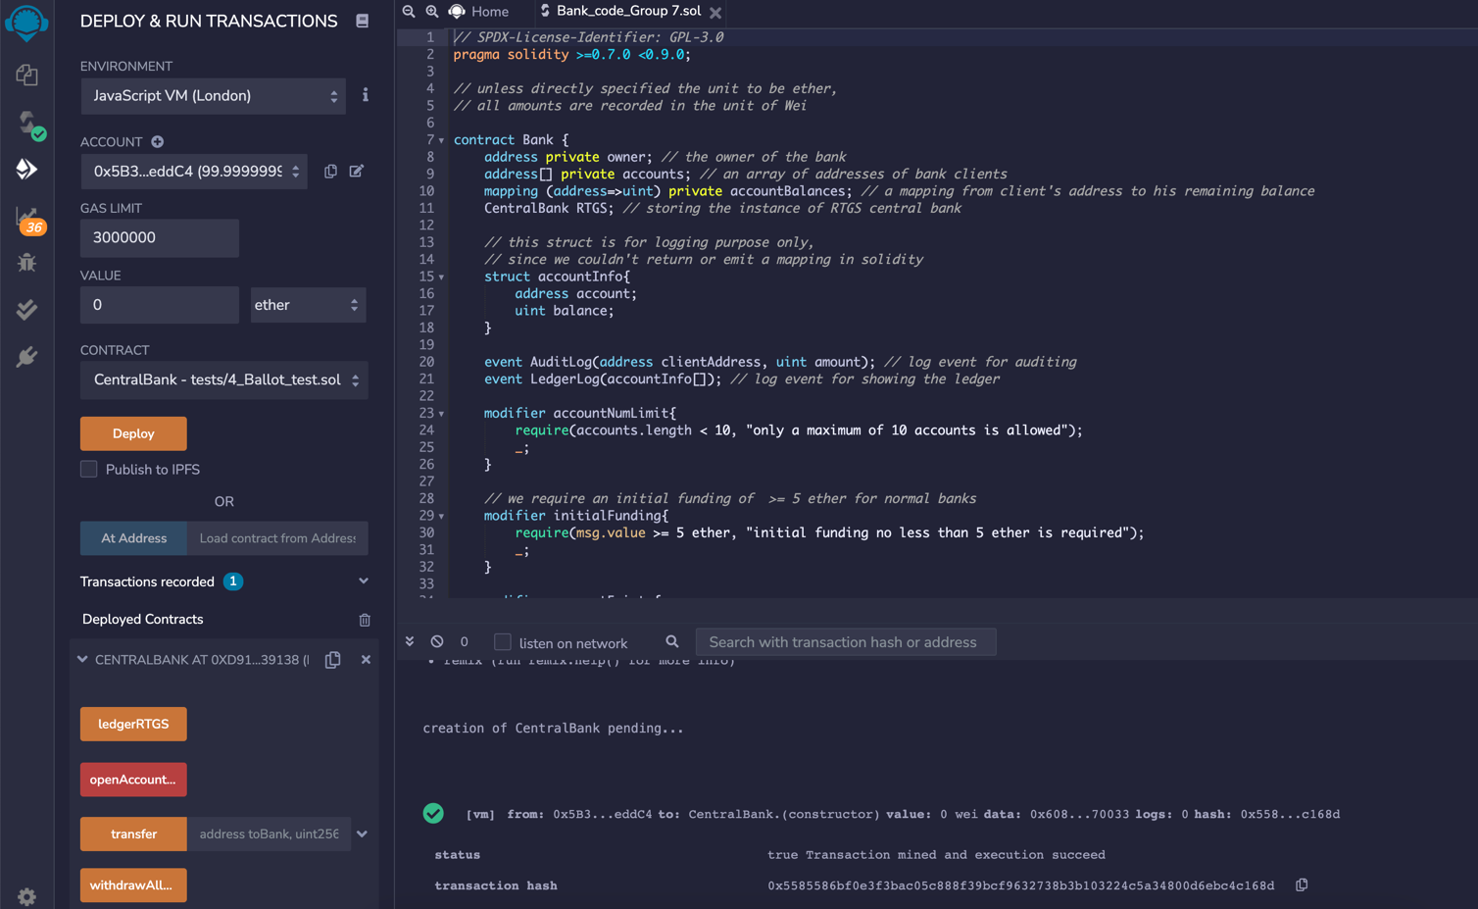

Deploy Central Bank

Address of Central Bank

Central Bank successfully deployed

1. **Deploy bank 1 & 2**

Then we selected two new accounts to be the owners of bank 1 & 2, respectively. By inputting 5 ethers in the value of message and clicking deploy (with bank contract), banks 1 & 2 are successfully deployed. Take Bank 2 as an example for screenshot:

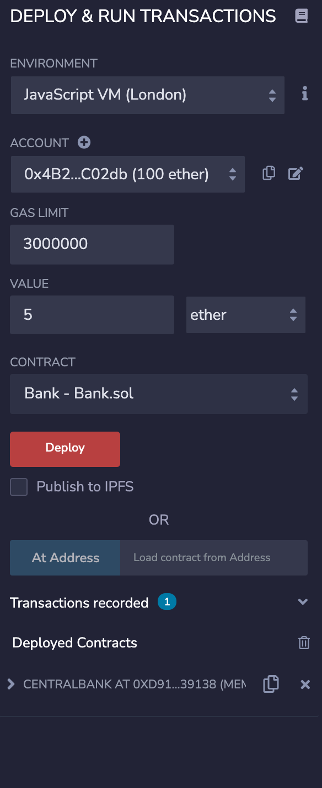

Initial funding of 5 ethers

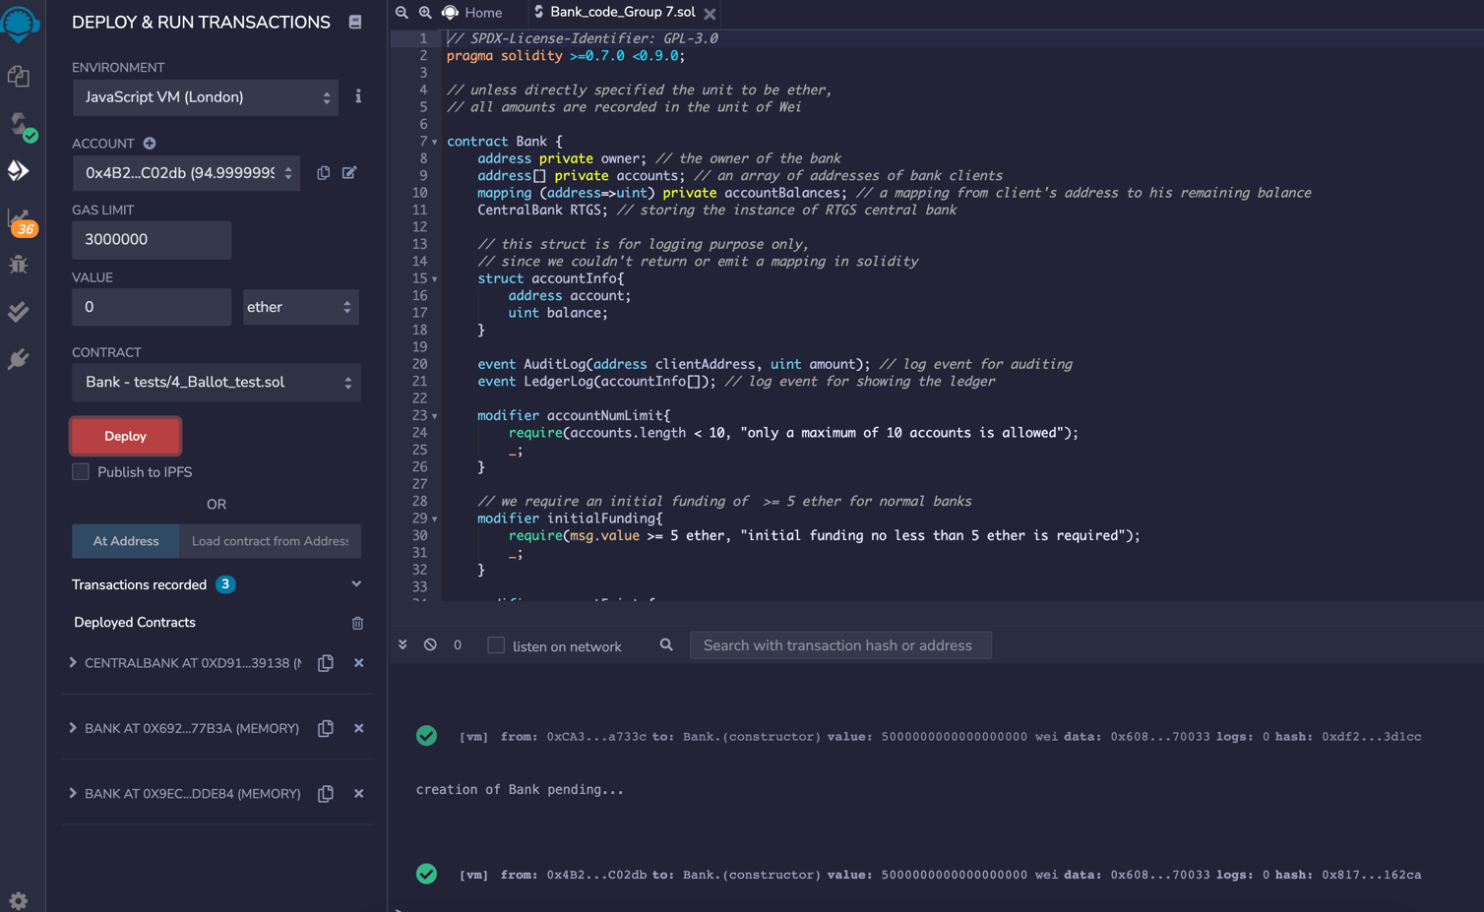

Bank 1&2 successfully deployed, each with initial funding of 5 ethers from their respective owner

Owner of Bank 2

Deploy Bank 1 & 2

1. **Register bank 1 & 2 with RTGS**

Then, by entering central bank’s address in “registerRTGS” box as the screenshot shown below, we registered bank 1 with RTGS. Same step for bank 2 registration.

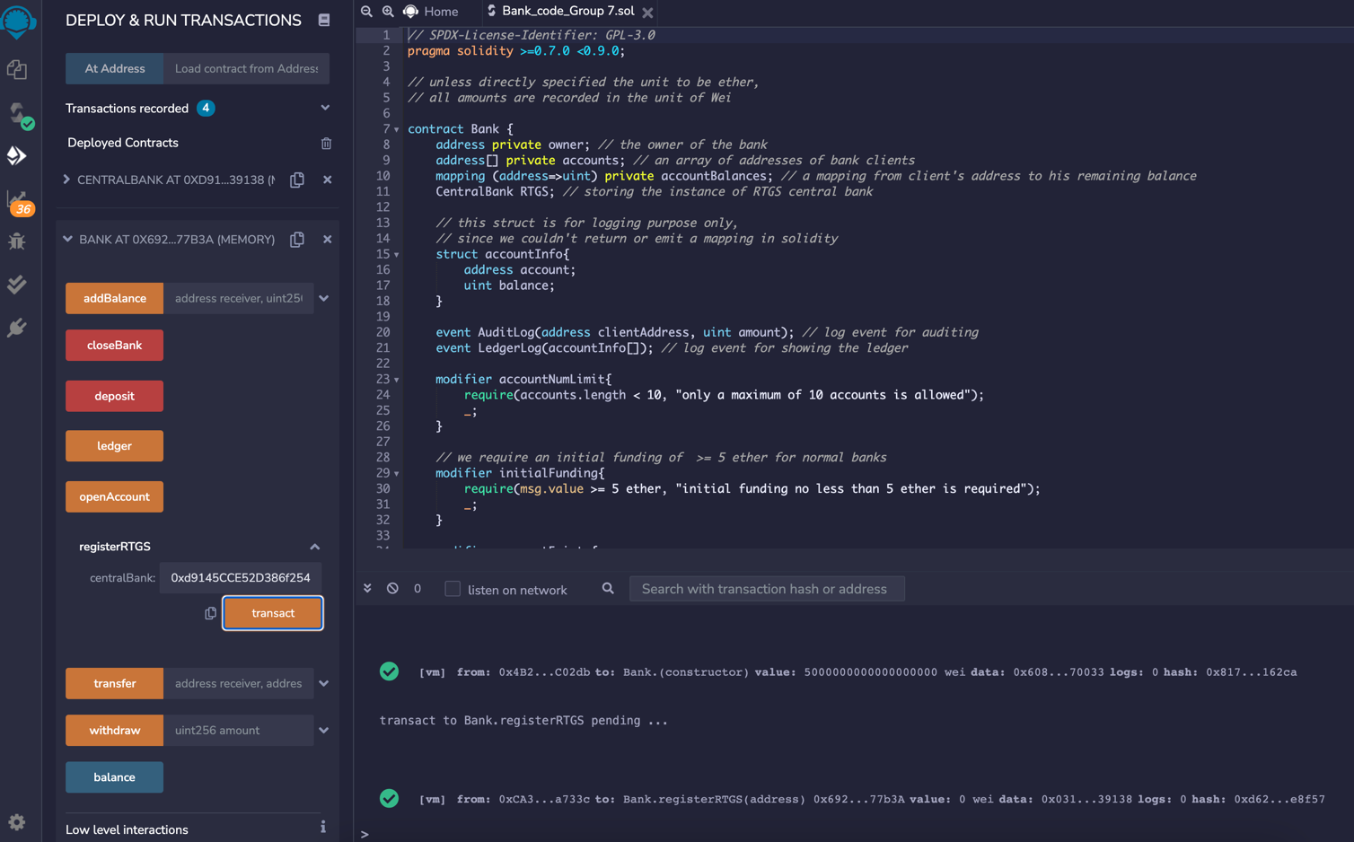

Register bank 1 with RTGS

Bank 1 successfully registered an account and deposited 3 ethers at RTGS bank

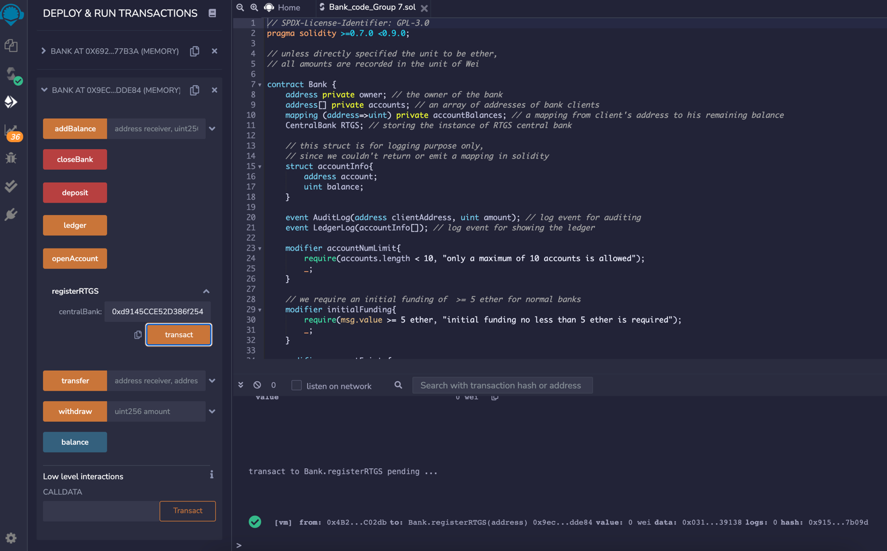

Bank 2 successfully registered an account and deposited 3 ethers at RTGS bank

Register bank 2 with RTGS

1. **Show ledger of RTGS**

After we registered bank 1 & 2 with RTGS, bank 1& 2’s information documented by central bank, and we are able to see it in ledger of RTGS. As the picture shown below, we can see bank 1 & 2’s address and their balance in central bank.

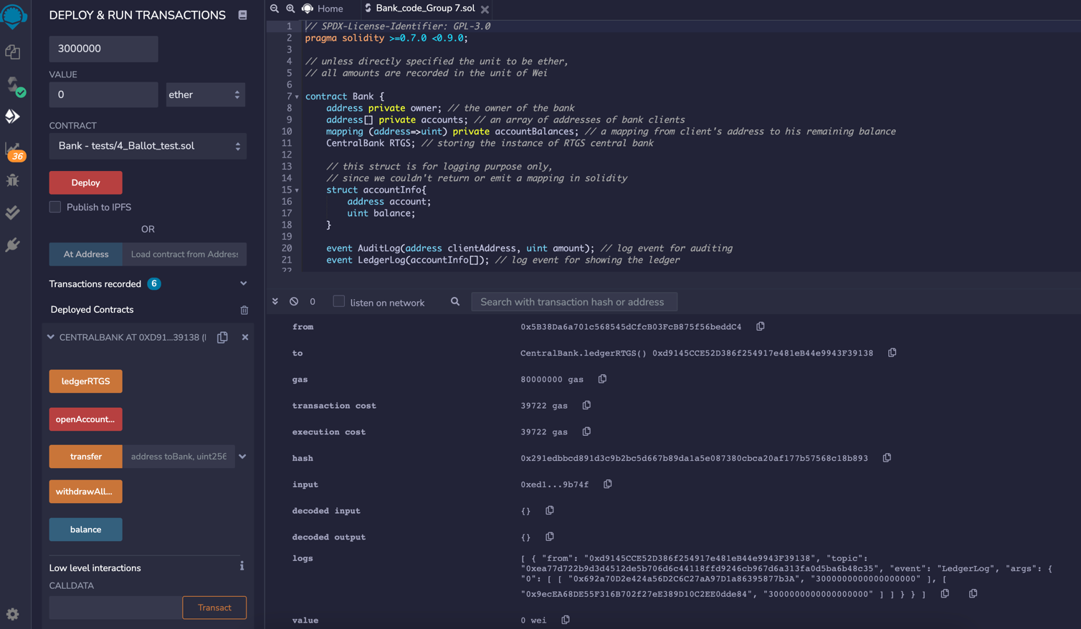

Ledger of RTGS shows bank 1&2’s information

1. **Open acct 1 & 2 with bank 1 & 2 respective**

Again, we selected 2 new accounts to be account 1 & 2, then click “openAccount” respectively in bank 1 & 2’s operation platform, we opened account 1 and 2 in bank 1 and 2 respectively.

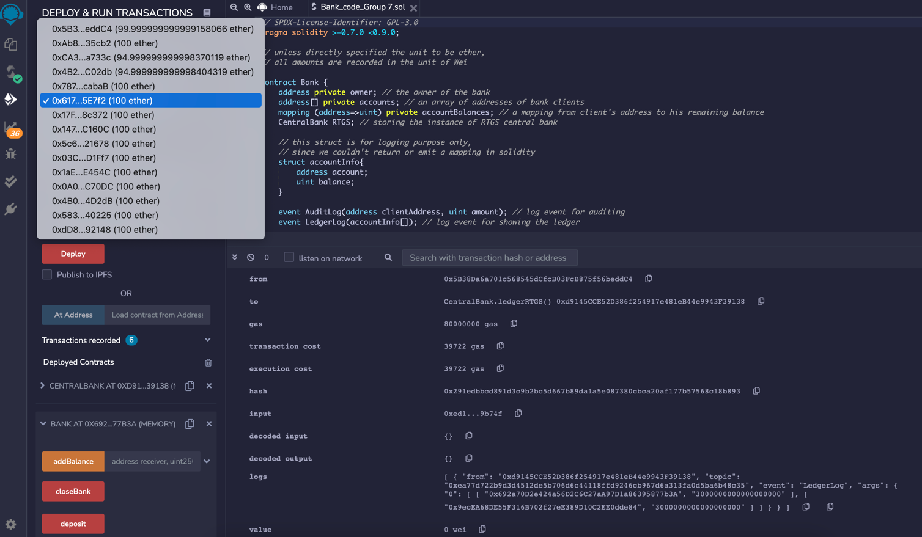

Choose an account address for account 1

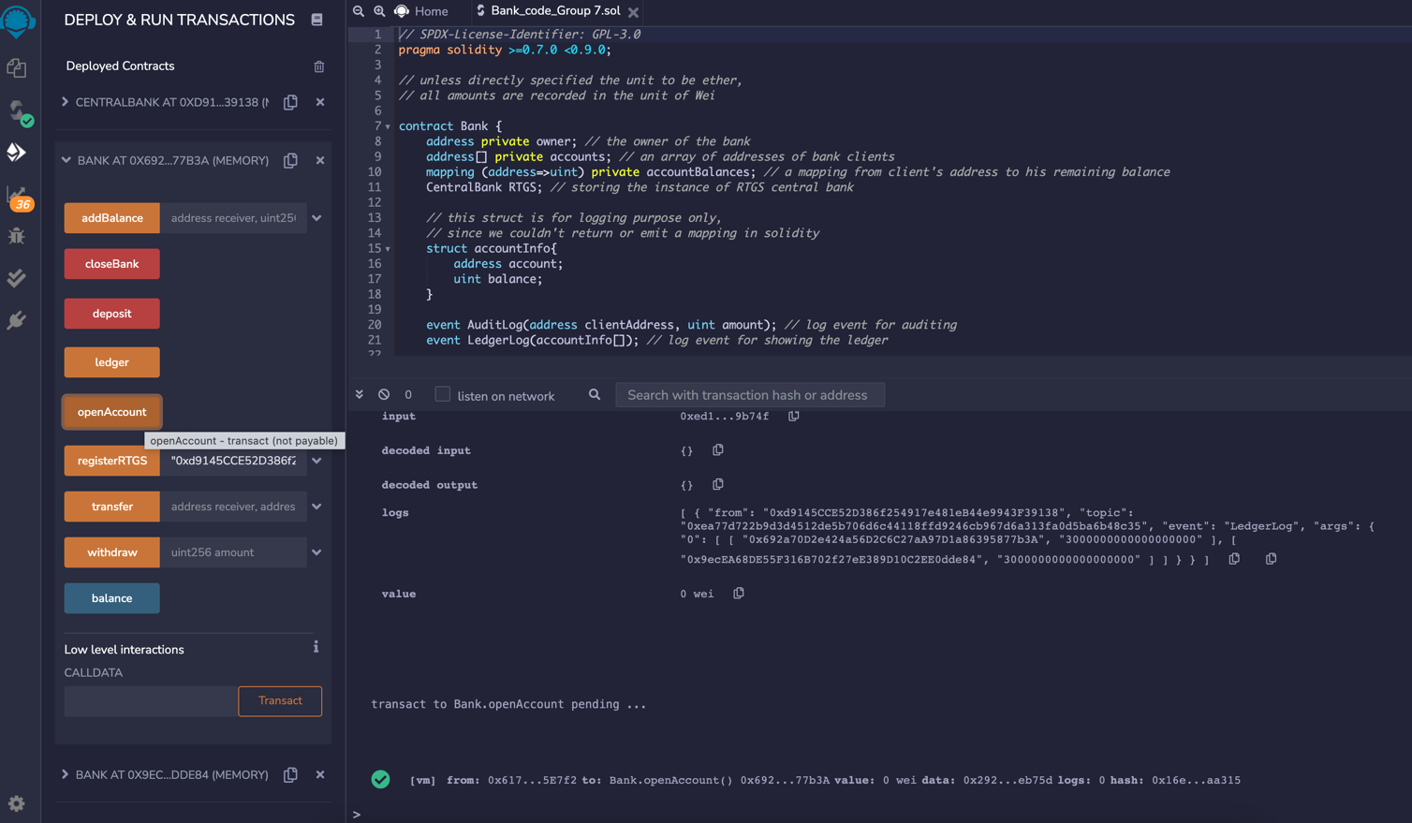

account successfully opened in bank 1

Open account 1 in bank 1

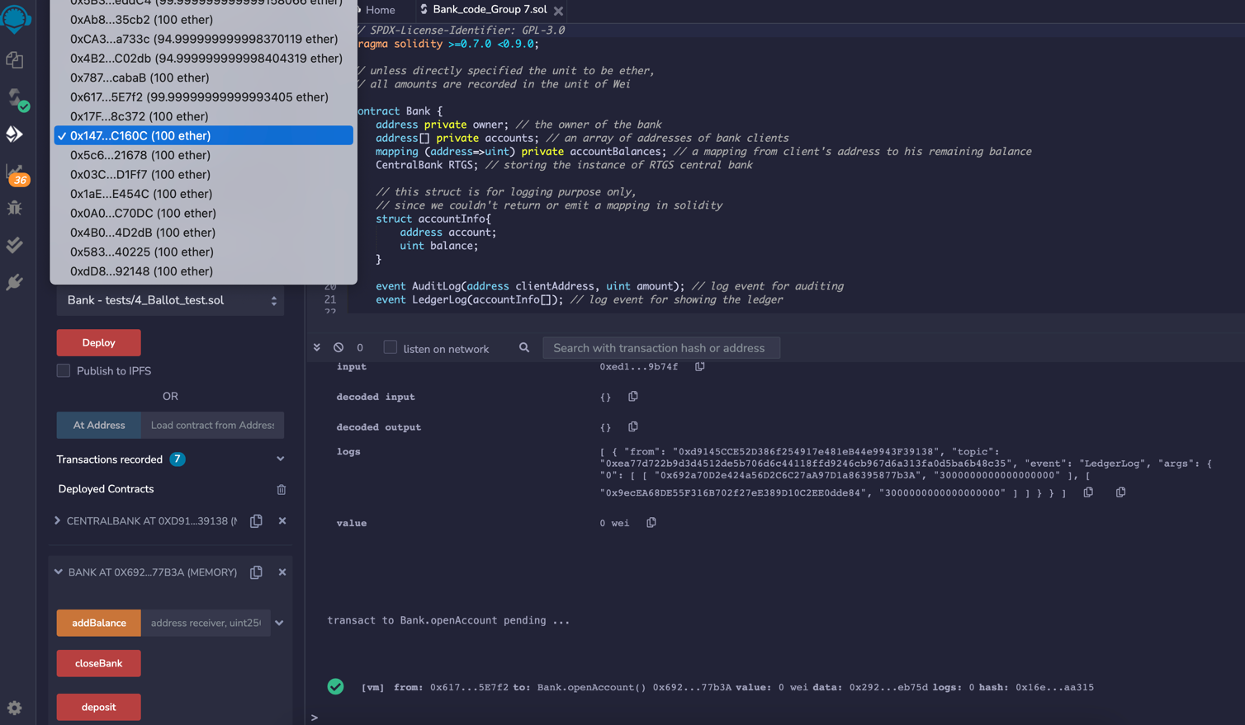

Same step for account 2, select an account

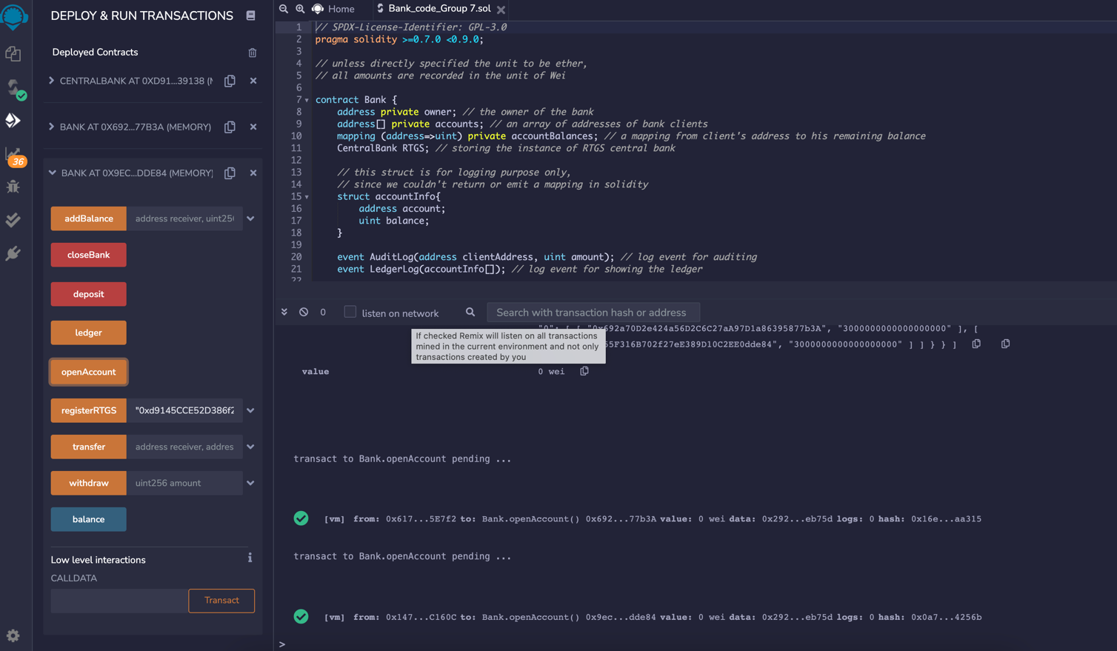

account successfully opened in bank 2

open account 2 in bank 2

1. **Deposit in bank 1 & 2**

After we open account 1 & 2 in different banks, we can then deposit with the account. As the screenshot shows, we selected account 1 as an example, and we aim to deposit 10 ethers in bank 1 (7 ether for account 2 in bank 2). By enter that information in box and click deposit the transaction successfully operated.

Account 1 selected

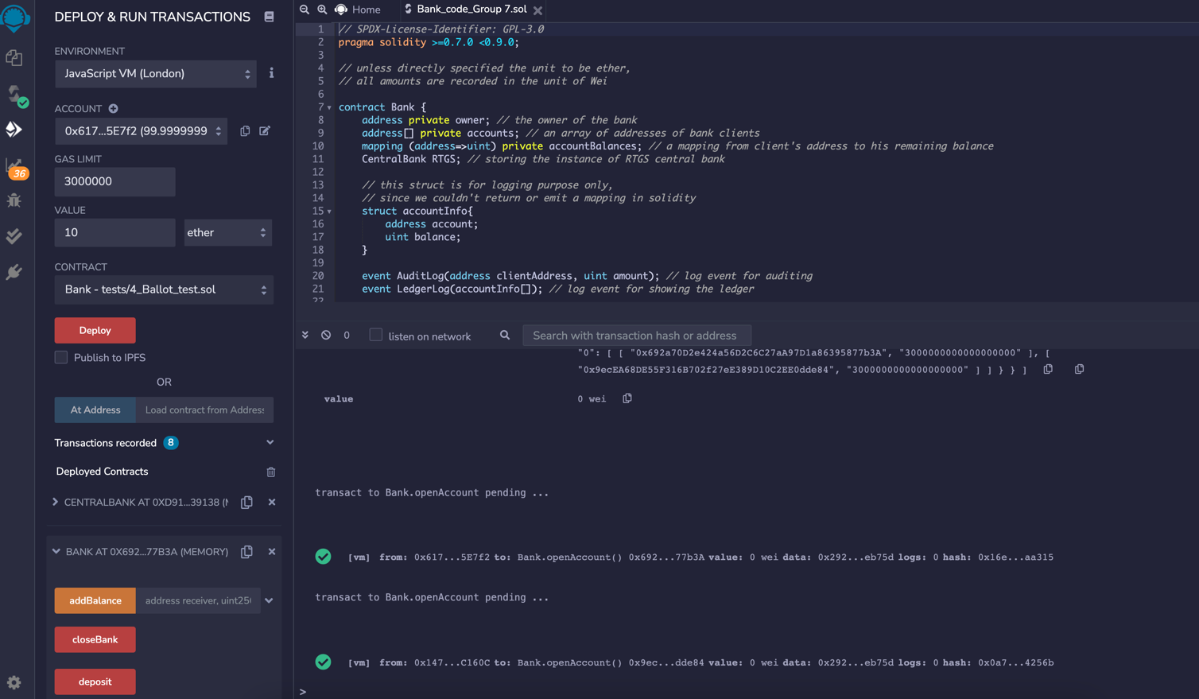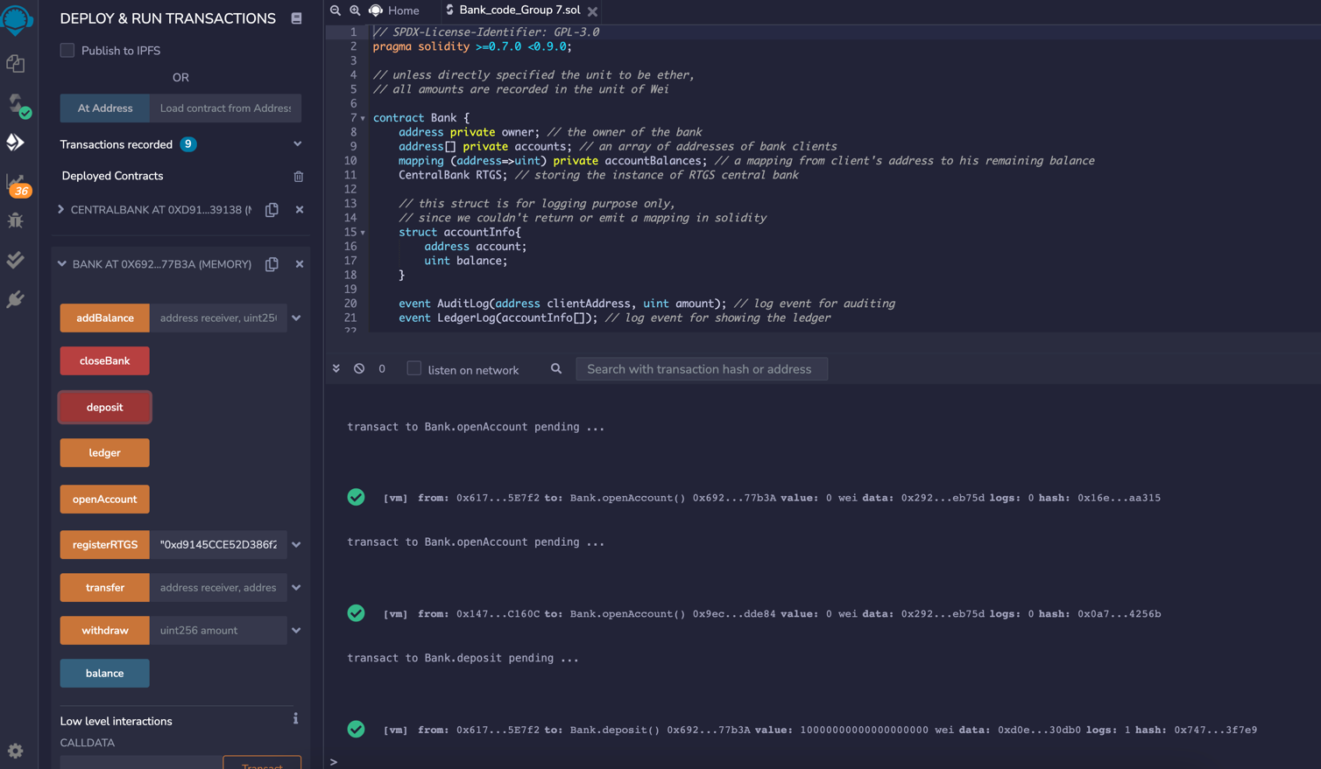

10 ethers successfully deposited in bank 1

Deposit 10 ether

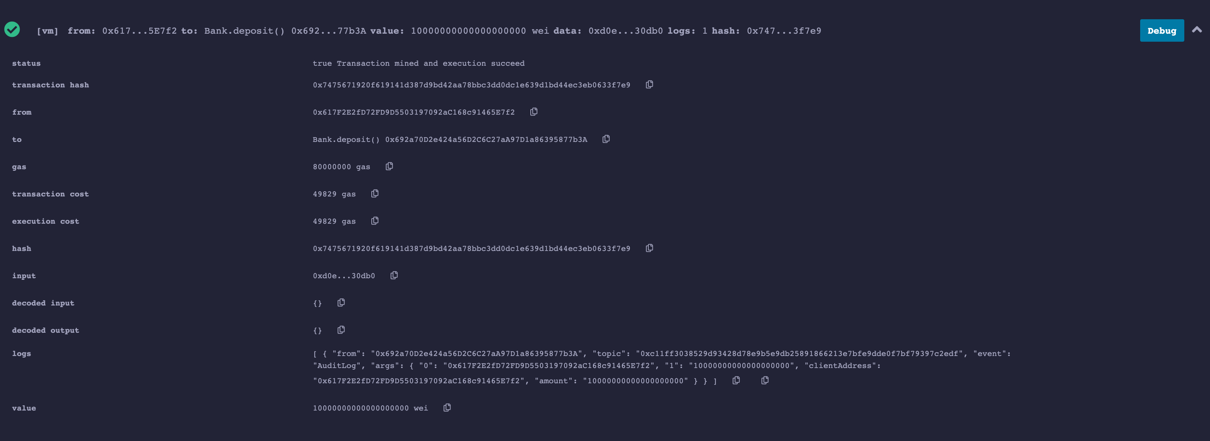

Audit Log emitted for deposit

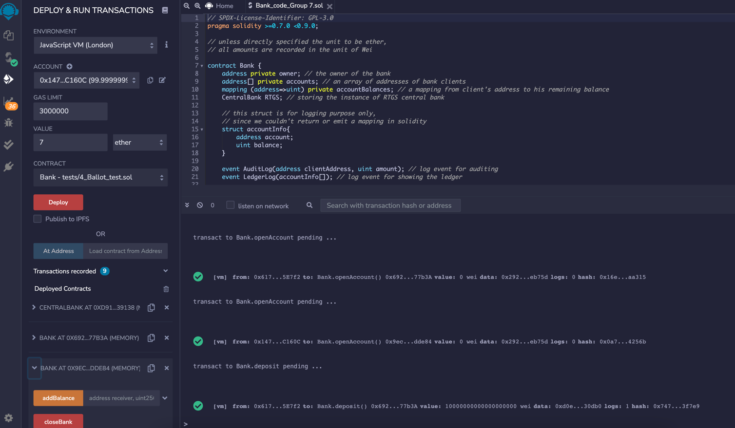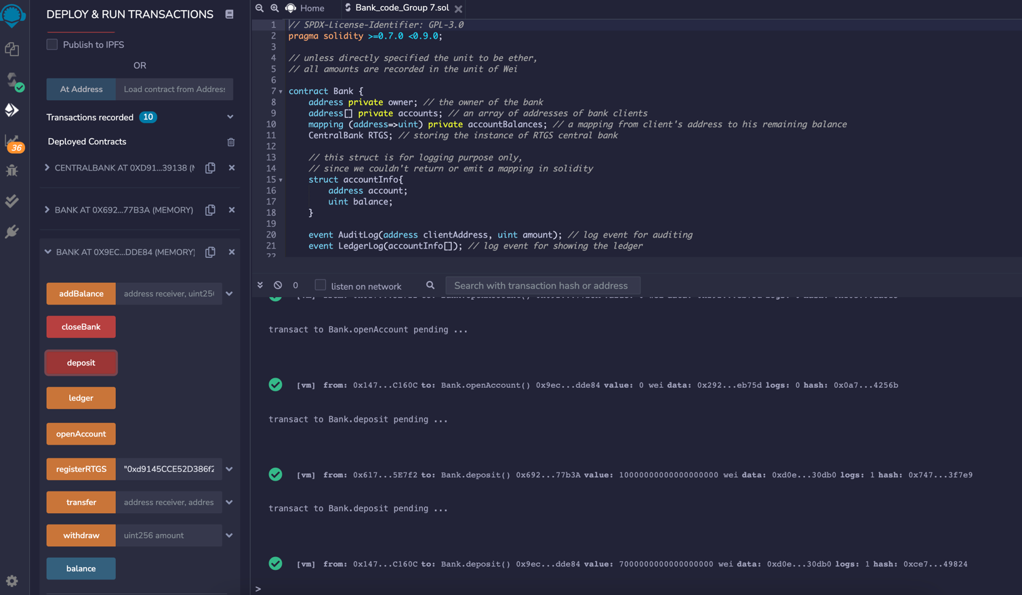

make a 7-ether deposit for account 2 in bank 2

Select account 2

7 ethers deposit successfully saved in bank 2

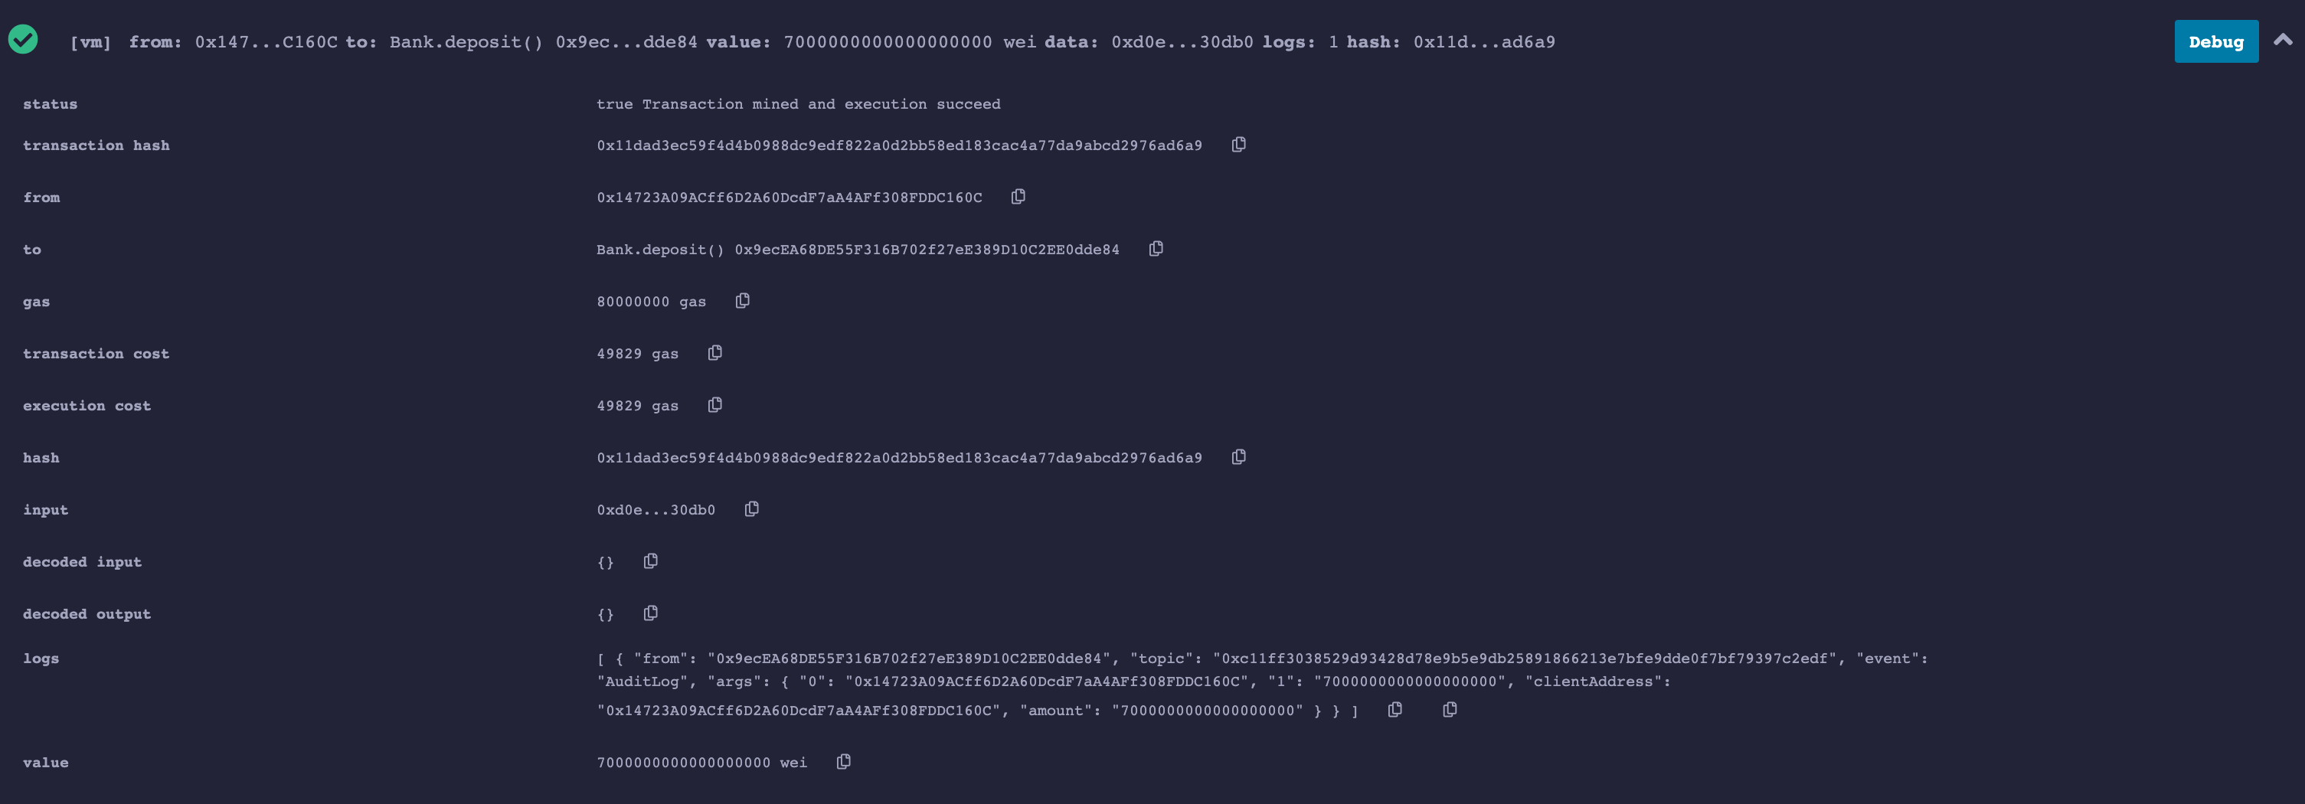

Audit Log emitted for deposit

1. **Show ledger of bank 1 & 2**

After we made deposit, each bank would have the record of clients’ balance. So, we look up ledger of each bank. For bank 1, it shows account 1 saved 10 ethers so that it now has 10 ether balance in bank 1. and for bank 2, its ledger shows account 2 saved 7 ethers.

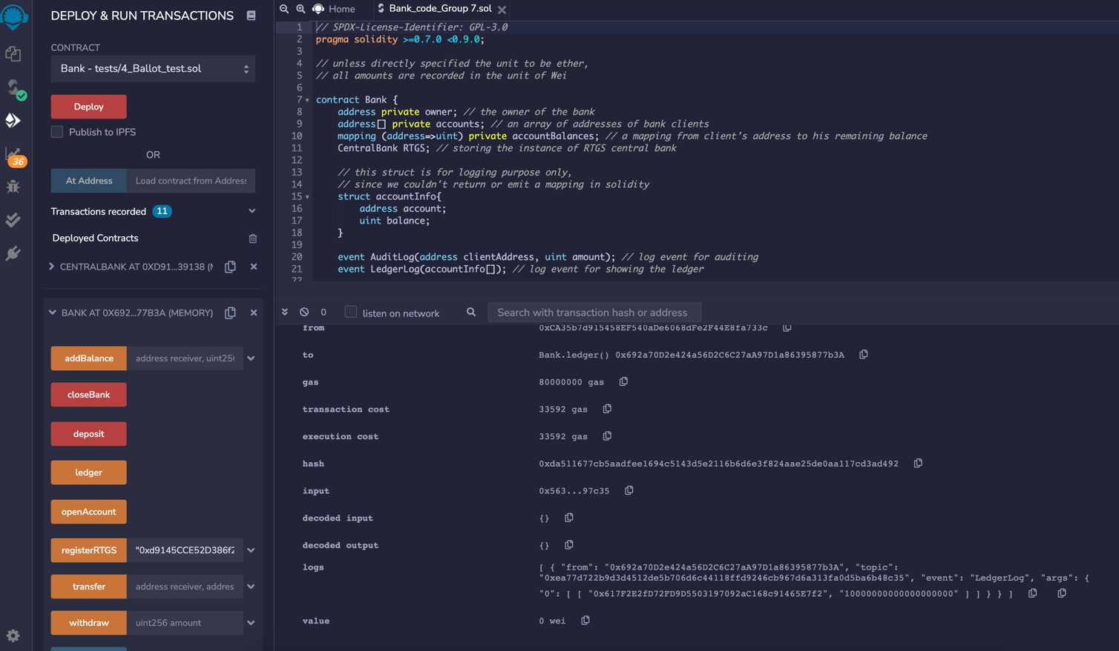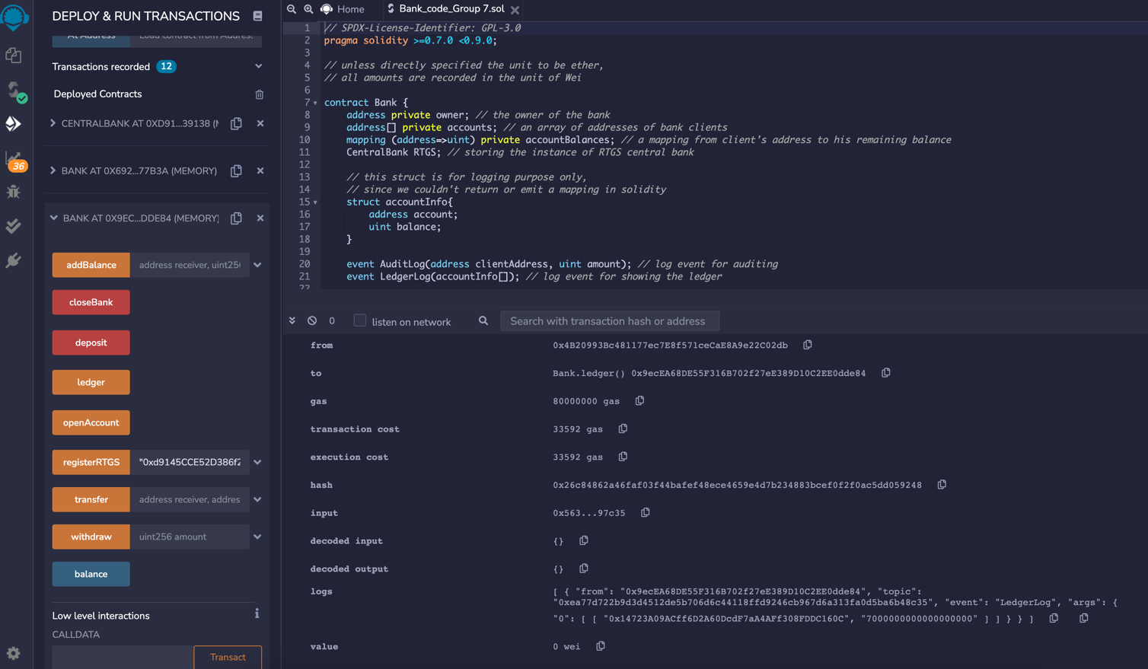

Bank 1’s ledger: 10 ethers for account 1

Bank 2’s ledger: 7 ethers for account 2

1. **Transfer money from acct 1 to 2**

Now we want use account 1 transfer money to account 2, so we select account 1 first, and open bank 1 operation platform. We firstly enter account 2’s account number (address), then bank 2’s account number (address), and the amount of money (the unit is Wei here) we want to transfer, then click transact.

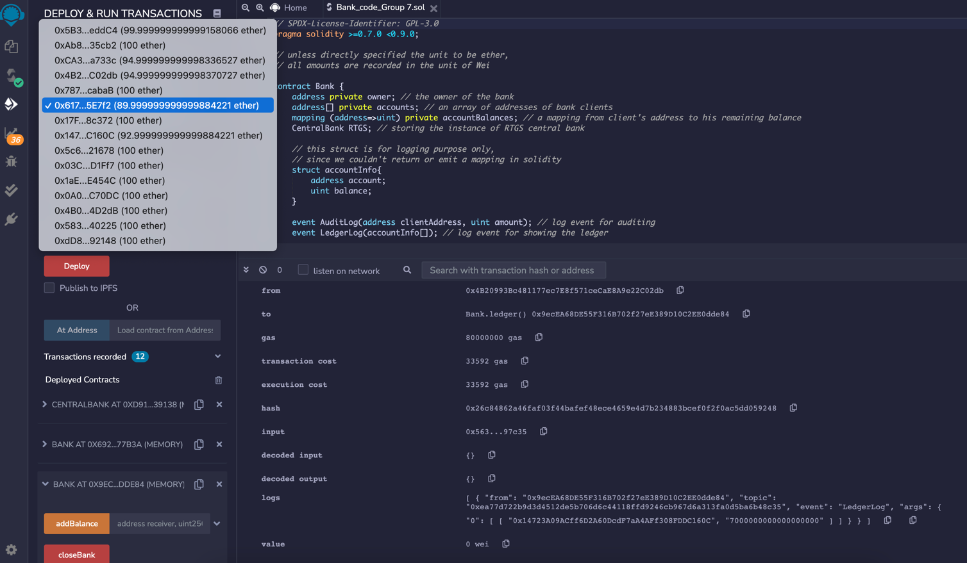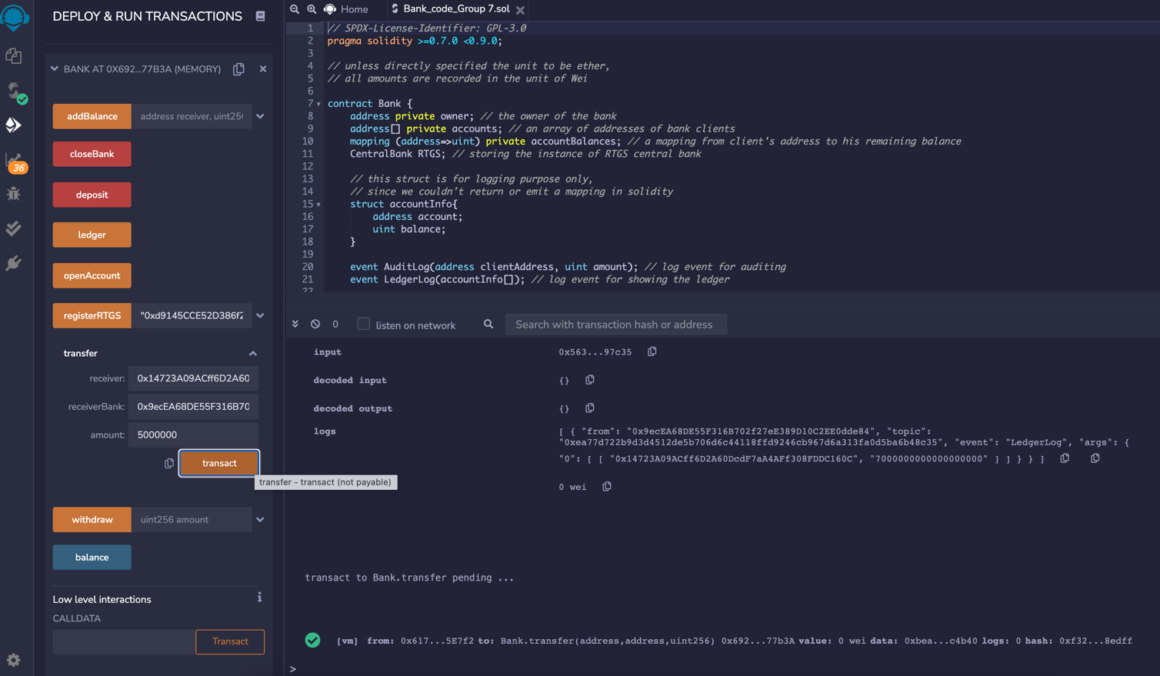

Then we input the address of account 2, then the address of bank 2 (since account 2 associate with bank 2), and the transfer amount as to make that transfer

Firstly choose the account 1 address

1. **Show ledger of bank 1 & 2**

After the transaction succeed, banks 1 & 2 would have record indicating this transaction, to look detailed information about this transact and account information, we opened ledger of bank 1 and 2 as the picture shown below.

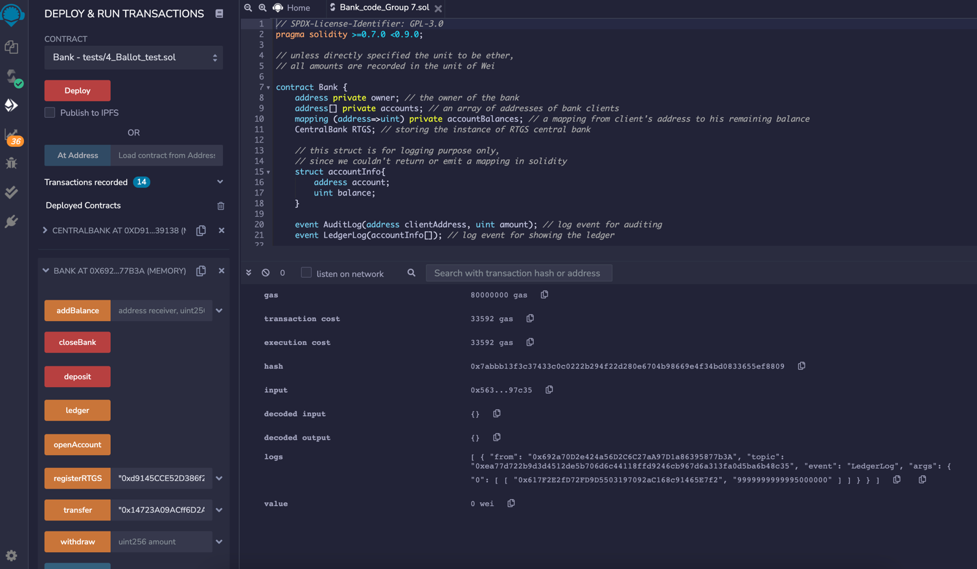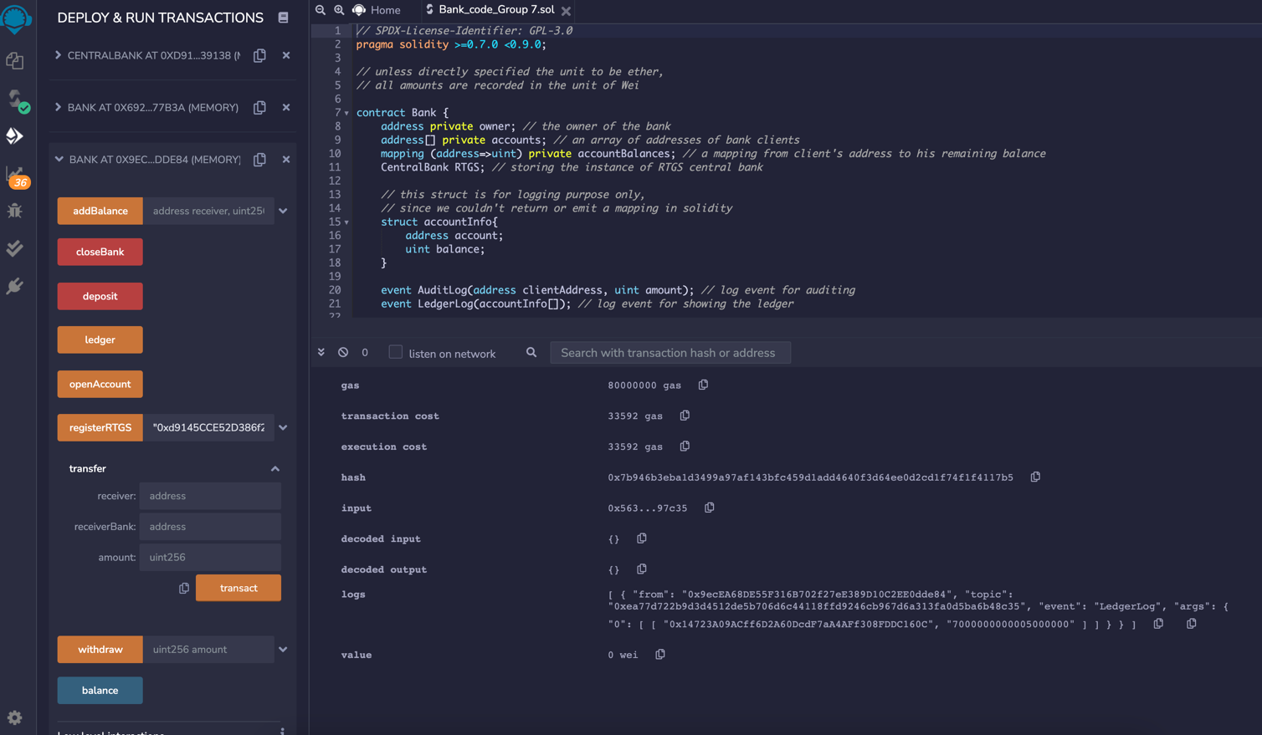

An increase of 5000000 Weis in account 2, which has been transferred from account 1, reflected on the ledger

A decrease of 5000000 Weis in account 1, which has been transferred to account 2, has been reflected on the ledger

1. **Show ledger of RTGS**

As the transaction need to go through central bank, we could also look ledger of RTGS to see this transaction.

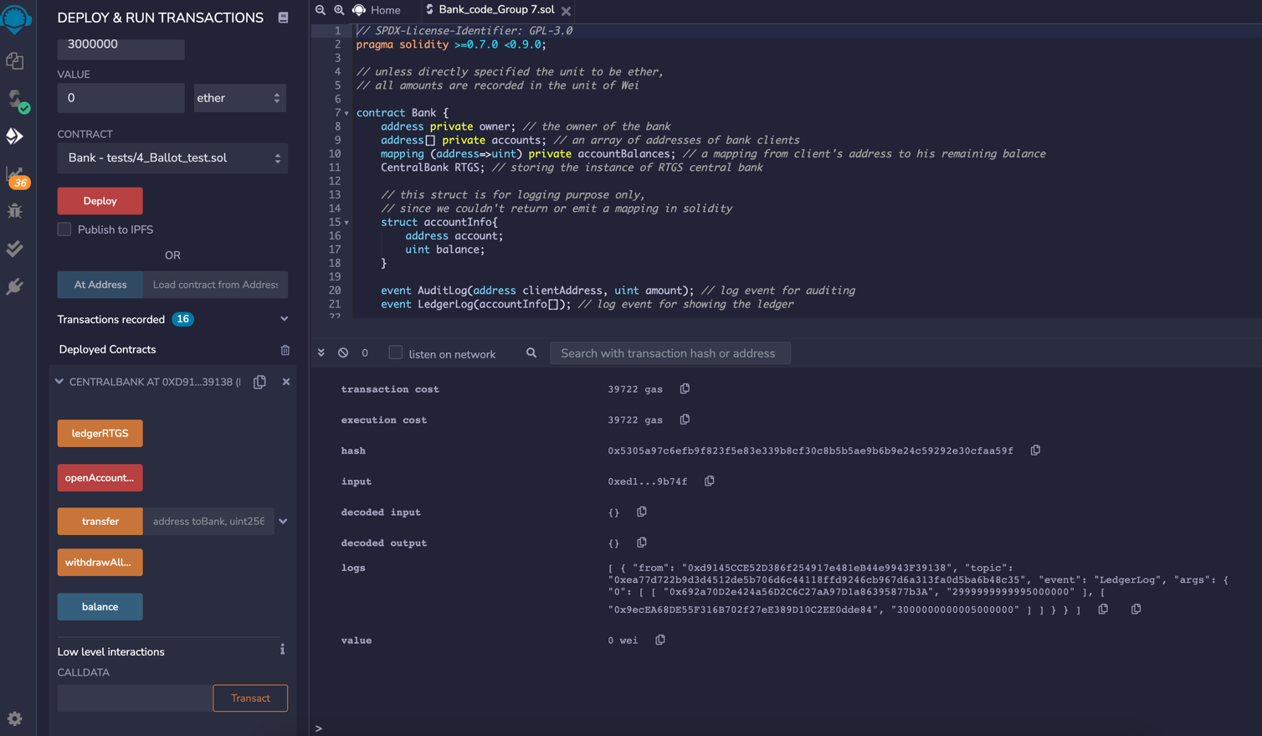

From the central bank RTGS, we also saw a decrease of 5000000 Weis in bank 1 account and an increase of 5000000 Weis in bank 2 account

**Withdraw & Balance**

We could not only transfer money between accounts, but also withdraw money and see the balance of account. Take account 2 as an example, we could use account 2 to withdraw a certain amount of money (not exceed its balance in bank 2), and we can see account 2’s balance in bank 2 clearly. Also, after the withdrawal, we could see that the money/balance of the owner of account 2 (an external account) increased by the specified amount. In other words, the money withdrawn was sent back to the original address.

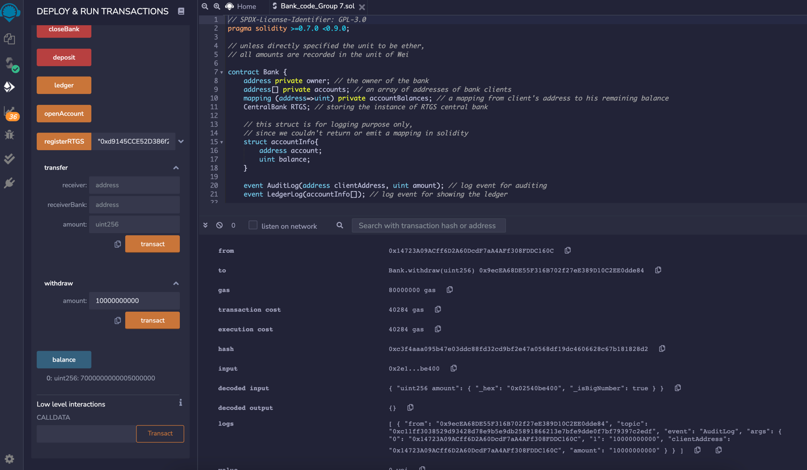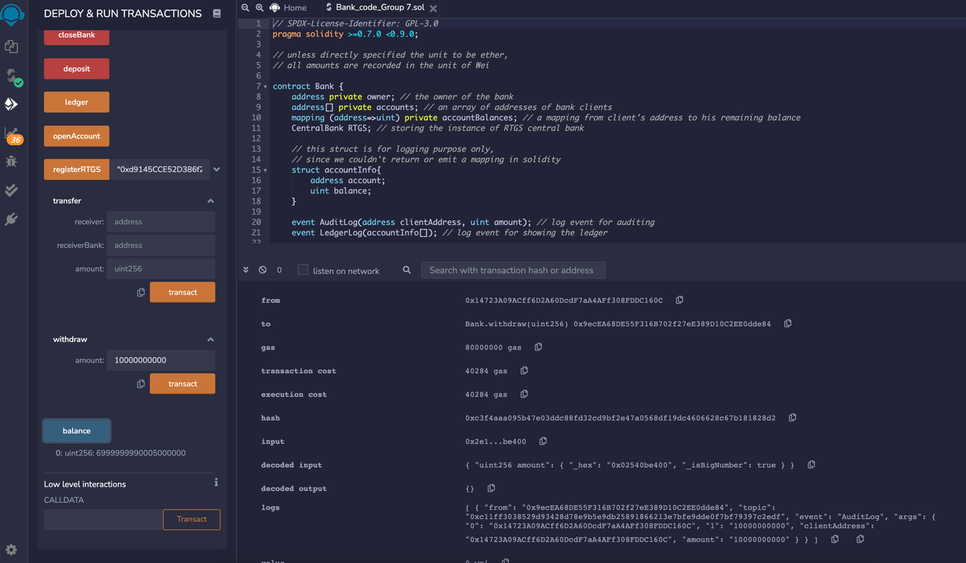

Audit Log emitted for withdrawal

Account balance after transaction

Account 2 withdraw 10000000000 Weis

Account balance before transaction

**Close bank (Take bank 1 as an example)**

We could also close normal bank if we want (only bank holder can close the bank). Firstly, we selected the owner of bank 1, and operate it in bank 1 platform, then we click “CloseBank”. After this, all client’s balances (here we only have account 1) in bank 1 and the initial funding of the bank owner (here it’s 5 ethers) would be returned to their original external account address, and information of bank 1 would be deleted in the ledger of RTGS.

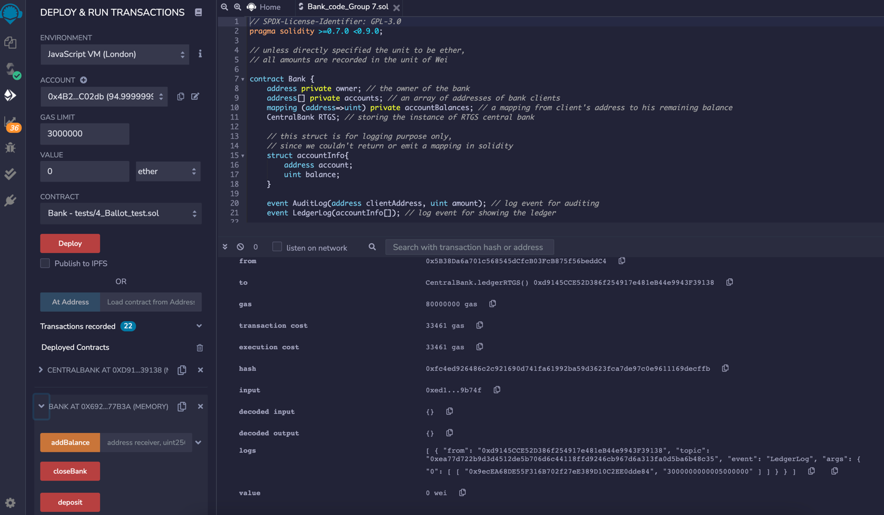

Select the owner of bank 1

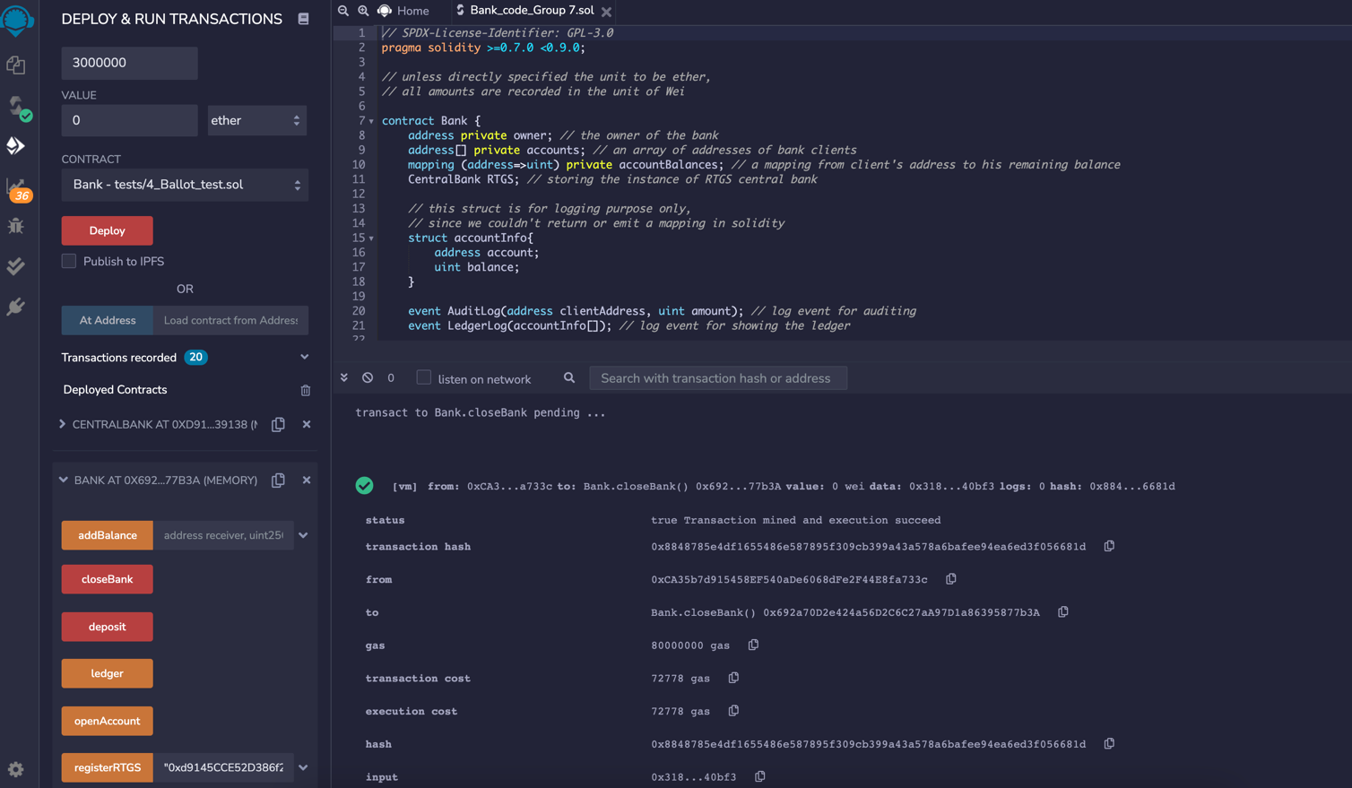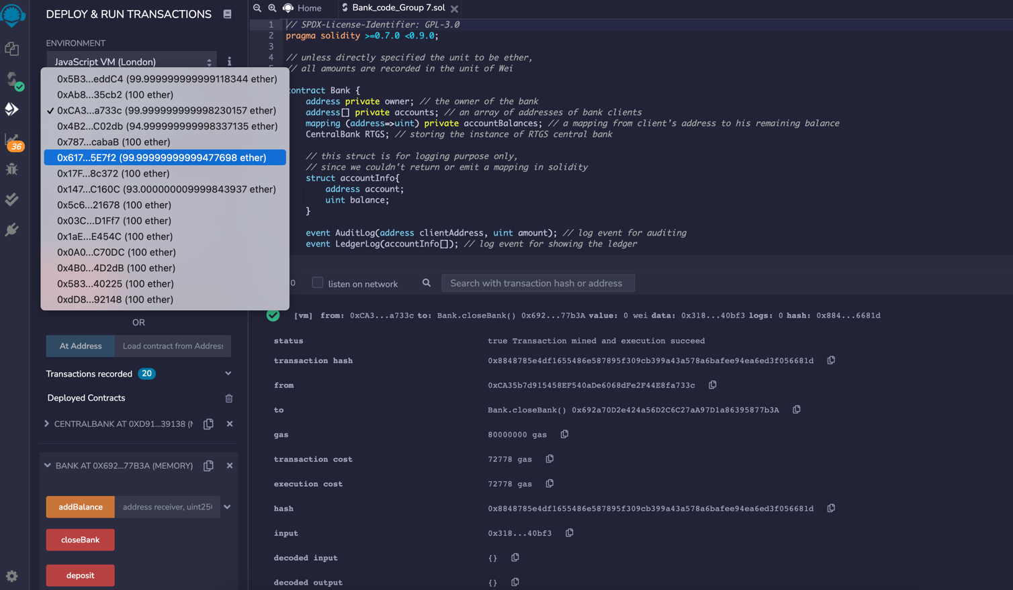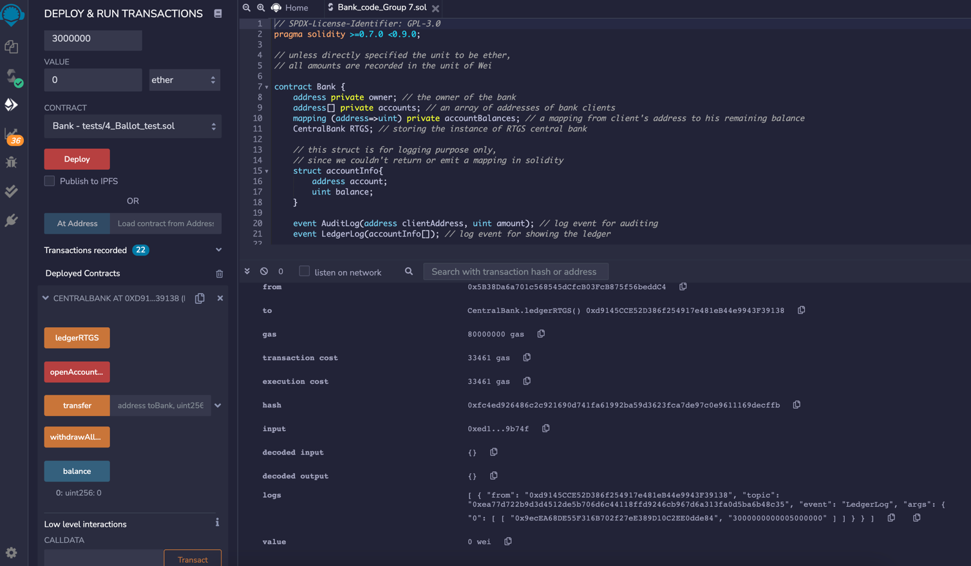

Money was returned to customer and owner after the close of bank

Bank 1 successfully closed

From the ledger of central bank, we saw no info for bank 1 after it’s closed